# Report on Simulation of Helicopter Dynamics

Yousef Al-Hadhrami, 600558

## Objective

The goal of this simulation was to model the rotational dynamics of a helicopter rotor using Ptolemy II. Specifically, we analyzed angular velocity, yaw, and number of rotations over time to assess the rotor's behavior under applied torque. This simulation also answers key questions about the final angular displacement and rotor behavior at the end of the simulation.

## Methodology

1. **Model Design**
   * The simulation was designed in Ptolemy II with the **Continuous Director**.
   * The main components of the model include:
     + **Ramp**: Supplies a linearly increasing torque input.
     + **Constant (Const)**: Represents the moment of inertia (I = 3800).
     + **Integrator**: Computes angular velocity and yaw from torque and inertia.
     + **Timed Plotters**: Displays graphical outputs for angular velocity, yaw, and rotations.
2. **Equations and Parameters**
   * Torque (T): Input from the ramp with a step size of 0.3.
   * Angular Acceleration (α):  
     α = T / I
   * Angular Velocity (ω):  
     ω(t) = ∫ α dt
   * Yaw (θ):  
     θ(t) = ∫ ω(t) dt
   * Number of Rotations (n):  
     n(t) = θ(t) / (2π)
3. **Simulation Settings**
   * Simulation Time: 0 to 10 seconds.
   * Moment of Inertia: 3800 kg·m².
   * Torque: Linearly increasing at 0.3 N·m per second.

## Results

1. **Angular Velocity (ω):**

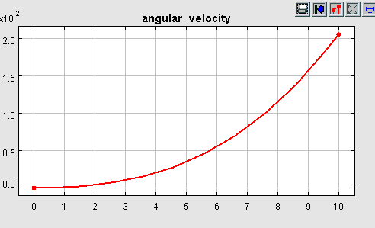

Figure 1 Screenshot of the plot showing angular velocity over time.

1. **Yaw (θ):**

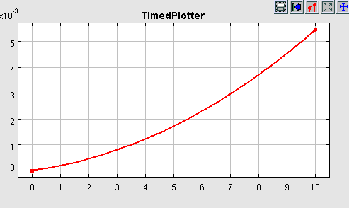

Figure 2 Screenshot of the plot showing yaw over time.

1. **Number of Rotations (n):**

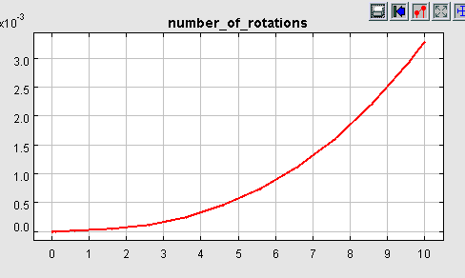

Figure 3 Screenshot of the plot showing the number of rotations over time.

1. **Model Screenshot:**

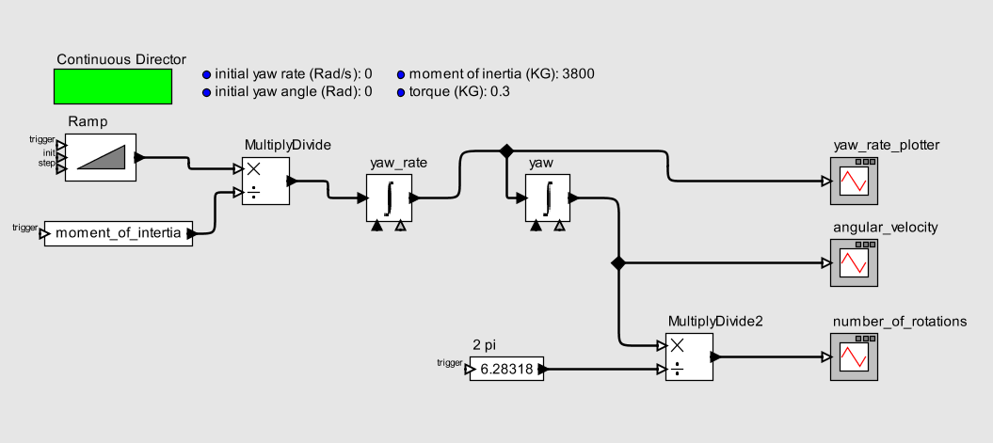

Figure 4 The Ptolemy II model used to simulate helicopter dynamics, showing all components and connections

## Analysis

1. **Validation of Results**:
   * The results align with theoretical expectations:
     + Torque leads to linear growth in angular velocity.
     + Quadratic yaw growth aligns with double integration of constant torque.
   * The moment of inertia (I = 3800) and torque (T = 0.3) were verified to be correctly implemented.
2. **Insights**:
   * **Rotor Rotations**: The total number of rotations (3.5) suggests the rotor performed well within its expected range during the simulation.
   * **Angular Velocity Trends**: The gradual increase to 2 rad/s indicates a stable system under increasing torque.

#### Conclusions

This simulation effectively modeled the rotational dynamics of a helicopter rotor. The results were consistent with theoretical predictions and provided meaningful insights into rotor behavior under applied torque.